

|  |  |  |
| --- | --- | --- |
| 04/07/2023 | Credit Card |  |
|  |  |
|  | Default Project |  |
|  | Wireframe |  |

Vaibhav Srivastava

Yash Kumar Singh

CREDIT CARD DEFAULT PROJECT

About the User Interface:

URL - https://www.kaggle.com/datasets/ealtman2019/credit-card-transactions

I designed an attractive user interface, in which a user can enter the attributes of the customer, which are the major predictors of credit card default as per the XGBoost Classifier Model.

They will be given as an input to the model, it makes a prediction of the probability of default in the backend and displays it on the front-end page of the user.

Entire webpage was designed by using Dash library in python using html-core-components and dash-core-components(dcc) and call-backs decorator.

Front-end of my website looks like below:

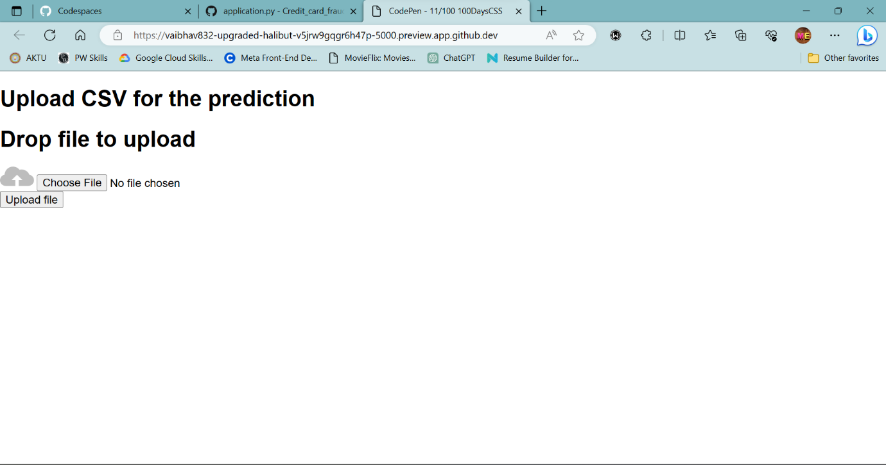

1 | P a g e